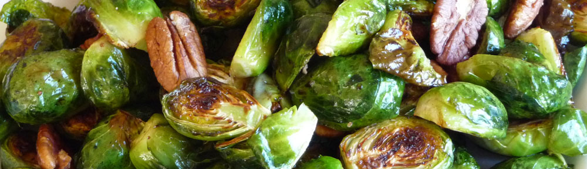
Roasted Brussels Sprouts

Hold Everything!

Now’s the time to try Brussels sprouts as their season is about to end. Quick and vegan Toasted Brussels Sprouts are sooo delicious, I even changed today’s post so as to get this recipe to you asap—this way, as I’m doing, you'll be able to enjoy them at least a couple of times before they are no more until the Fall when their season begins anew.

You Are Going to Love These!
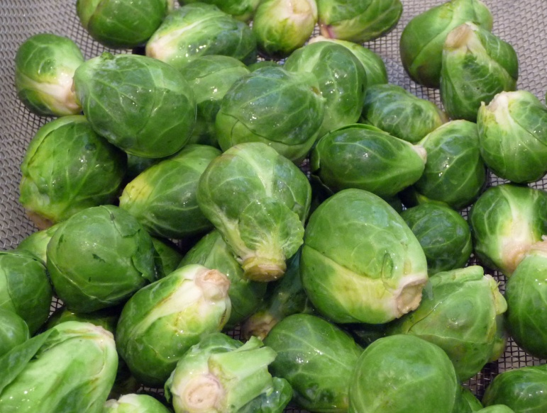
True, many people say they don’t like Brussels sprouts—often because they are bland-tasting, or they have eaten them overcooked and smelling of sulfur. It is so amazing what roasting at a very high temperature does—they don’t even taste like Brussels sprouts—instead they have an unexpectedly fresh taste and caramelized sweetness.

We have Cook’s Illustrated to thank for this roasting method. The addition of a very small amount of water allows the sprouts to steam during the first half of their cooking time, making them tender all the way through. And the very high temperature throughout assures that the sprouts are gorgeously caramelized and richly flavored.

Brussels sprouts are more than delicious. They also are a nutrient-rich cruciferous vegetable with many, many health benefits. Now that there’s a way to prepare sprouts that brings out their best flavor, there’s no longer a reason not to prepare and enjoy them frequently.

How Shall We Serve Them?
- For me the basic recipe is my new favorite way to serve Brussels sprouts.
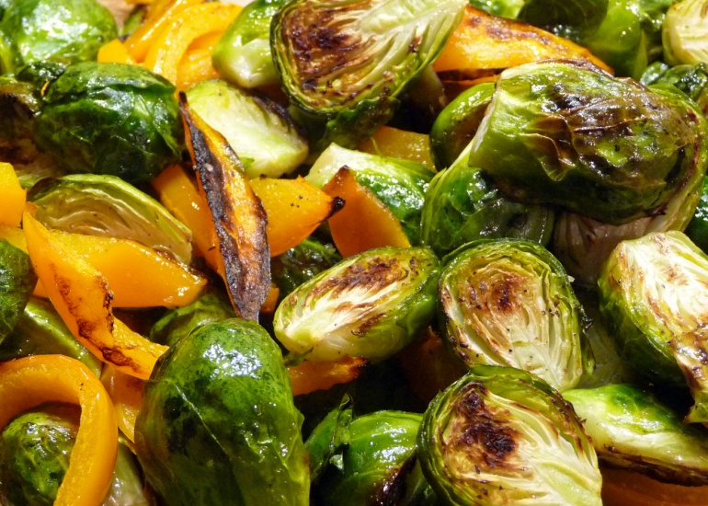
- Tonight I’ll try something new. I’ll be roasting the sprouts with strips of a sweet orange pepper. I’ll let you know how they turn out. ;-) FABULOUS!
- A little balsamic vinegar and a few toasted pecans or walnuts dresses them up for special meals from fall to mid spring, including as a side dish for the Thanksgiving table.
- Additionally, you could toss the roasted sprouts with a bit of fresh lemon juice, a large pinch of red pepper flakes and some finely grated Parmesan cheese.

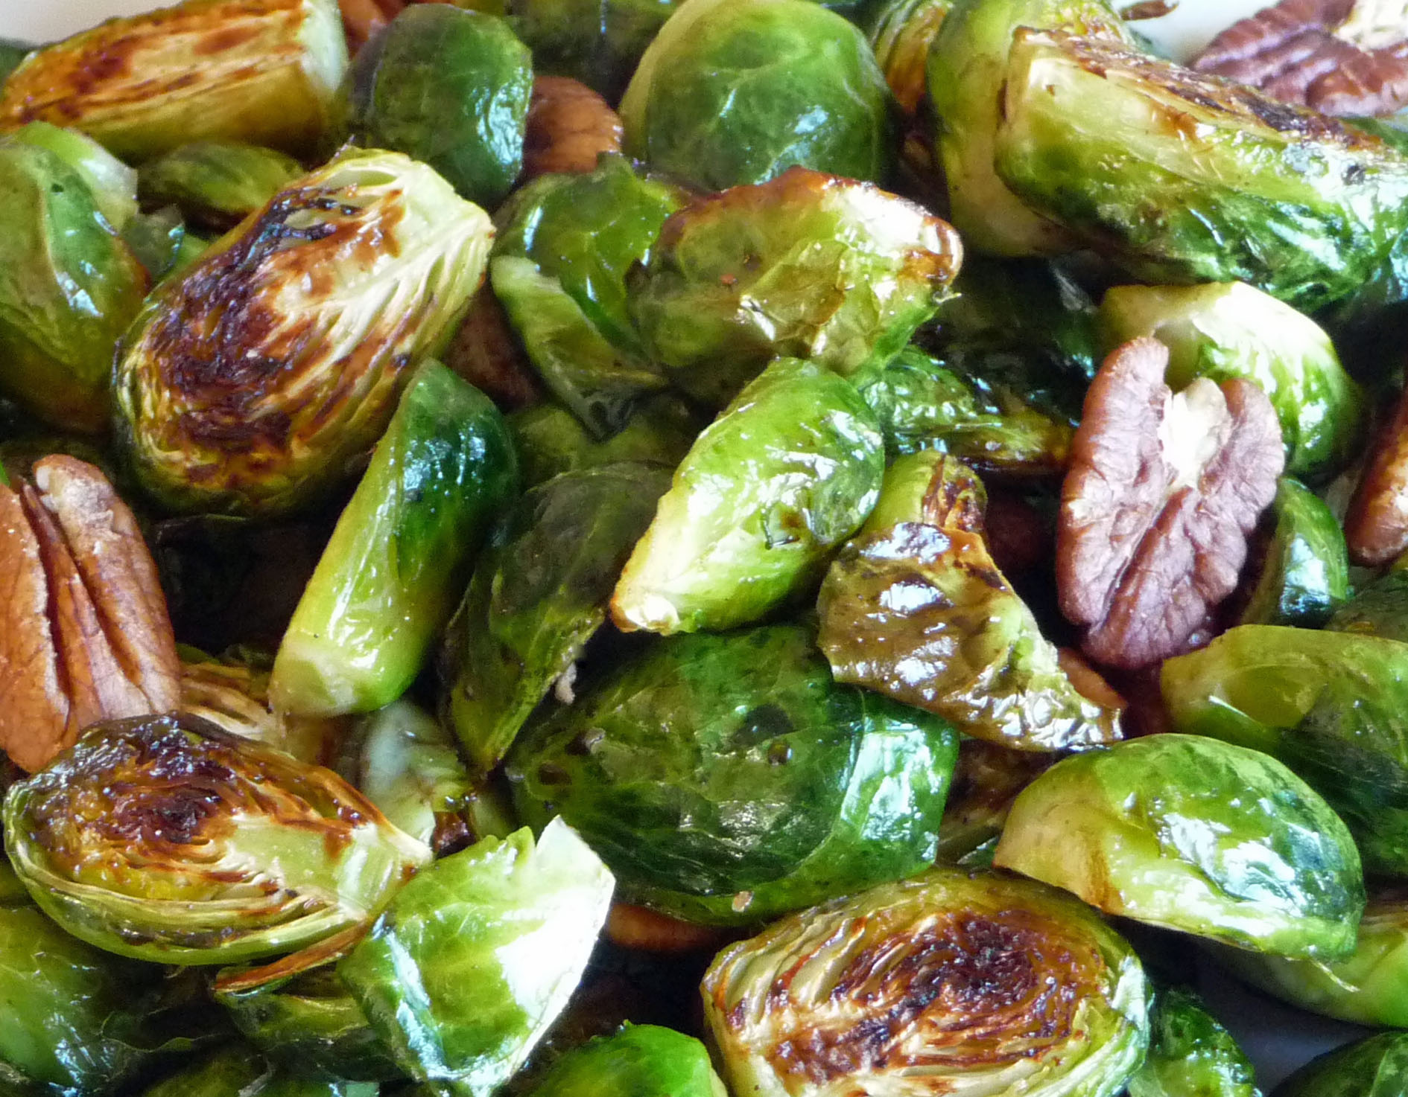

Roasted Brussels Sprouts
Adapted from a recipe by Andrea Geary in Cook’s Illustrated

Serves 3-4

1½ pounds Brussels sprouts, trimmed and halved
1½ tablespoons extra virgin olive oil
1 tablespoon water
¼ teaspoon coarse salt
Half a dozen twists freshly ground pepper

Preheat the oven to 500 degrees.

Toss the trimmed and halved Brussels sprouts with the rest of the ingredients.

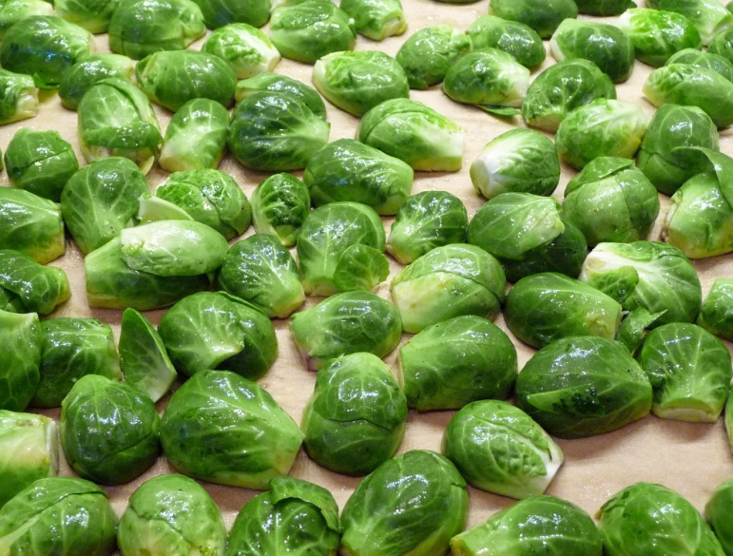
Line a rimmed baking sheet with parchment paper. Transfer the sprouts to the baking sheet, cut side down.

Cover the pan tightly with aluminum foil and place on the middle shelf in the preheated oven. Roast for 10 minutes.

Remove the foil using a pair of tongs to protect your hands from being burned by the steam.

Roast for another 10 minutes. Remove the sprouts from the oven and sprinkle them with additional salt and pepper to taste. Serve them hot as a side dish or as a vegan/vegetarian entrée.

Roasted Brussels Sprouts w/ Toasted Pecans or Walnuts & Balsamic Vinegar
The balsamic vinegar adds an additional touch of sweetness.

1/3 cup walnuts or pecans, toasted at 350 degrees for 7 minutes
2 teaspoons balsamic vinegar
Salt and freshly ground pepper to taste

Remove the sprouts from the oven and toss them with the balsamic vinegar, salt and pepper to taste and the toasted walnuts or pecans.

